📘 COLUMN-WISE EXPLANATION (2–3 Lines Each)
1. Customer_ID
A unique identifier assigned to each customer in the telecom system.
Used as the primary key to distinguish individual customer records.

2. Gender
Indicates whether the customer is Male or Female.
Useful for demographic segmentation and churn pattern analysis.

3. Age
Represents the customer’s age in years.
Older or younger customers may show different churn behavior.

4. Married
Shows whether the customer is married (Yes/No).
Family status can influence service usage and loyalty.

5. State
The state or region where the customer resides.
Helps analyze geographic churn patterns and network coverage impact.

6. Number_of_Referrals
Number of new customers referred by this customer.
Higher referrals usually indicate higher satisfaction and lower churn risk.

7. Tenure_in_Months
How long (in months) the customer has been with the company.
Short-tenure customers are more likely to churn.

8. Value_Deal
Special subscription or discount deal assigned (e.g., Deal 4, Deal 5).
Shows which promotional offers influence customer retention.

9. Phone_Service
Shows whether the customer subscribed to phone service (Yes/No).
Useful for analyzing churn among customers with basic services.

10. Multiple_Lines
Indicates if the customer has multiple phone lines.
Customers with multiple lines tend to be more committed and churn less.

11. Internet_Service
Specifies whether the customer has internet service (Yes/No).
Internet users often generate more revenue but may churn if dissatisfied.

12. Internet_Type
Type of internet connection: Cable, Fiber Optic, etc.
Certain types (like Fiber Optic) may show different satisfaction levels.

13. Online_Security
Shows if the customer has added online security services.
Additional services can increase retention and reduce churn.

14. Online_Backup
Indicates whether online backup service is subscribed.
Add-ons show customer engagement and influence churn probability.

15. Device_Protection_Plan
Represents whether the customer purchased device protection.
Customers with more add-ons usually show higher loyalty.

16. Premium_Support
Shows if the customer has premium or priority support.
Premium support users typically expect higher service quality.

17. Streaming_TV
Indicates subscription to TV streaming service.
Useful for studying entertainment-based service impact on churn.

18. Streaming_Movies
Shows if the customer streams movies through the telecom provider.
Can highlight customer preferences and service dependencies.

19. Streaming_Music
Indicates usage of the music streaming service.
Helps understand customer engagement with entertainment bundles.

20. Unlimited_Data
Shows whether the customer subscribed to unlimited data plans.
Customers with limited data plans may churn due to data overages.

21. Contract
Type of contract: Month-to-Month, One Year, Two Year.
Month-to-month customers churn the most; long-term contracts reduce churn.

22. Paperless_Billing
Indicates use of electronic billing (Yes/No).
Paperless users are often more tech-savvy and cost-sensitive.

23. Payment_Method
Method used for payments (Credit Card, Bank Withdrawal, etc.).
Auto-payment users tend to churn less compared to manual payment users.

24. Monthly_Charge
The monthly bill amount charged to the customer.
Higher charges may correlate with dissatisfaction and churn.

25. Total_Charges
Total amount billed over the customer’s entire tenure.
Used to estimate customer lifetime value and revenue patterns.

26. Total_Refunds
Total refunded amount given to the customer.
High refunds may indicate service issues or dissatisfaction.

27. Total_Extra_Data_Charges
Charges incurred for additional data beyond plan limits.
Excessive extra charges may lead to customer churn.

28. Total_Long_Distance_Charges
Charges for long-distance calls.
Useful for identifying customers with high usage patterns.

29. Total_Revenue
Total revenue generated from the customer using multiple services.
Higher revenue customers are more valuable and important to retain.

30. Customer_Status
Shows whether the customer Stayed or Churned.
This is the primary target variable for churn analytics.

31. Churn_Category
Categorizes the reason for churn (e.g., Competitor, Dissatisfaction).
Helps understand what type of customers are leaving.

32. Churn_Reason
Specific reason why the customer churned.
Provides deeper insight into customer dissatisfaction drivers.

📌 PROJECT GOALS (Clean 3–4 Line Explanation for Each)
1. Analyze Customer Data Across Multiple Dimensions
This project aims to explore customer information through different perspectives to understand behaviors and patterns. The analysis is divided into:
- Demographic: Age, gender, marital status
- Geographic: Customer distribution across states
- Payment & Account Info: Billing methods, charges, revenue patterns
- Services: Telecom services used and their impact on churn
This multi-level analysis helps identify factors influencing customer retention.

2. Study Churner Profile & Identify Marketing Opportunities
The goal is to understand which customers are leaving (churners) and why.
By studying their demographics, service usage, and behavior patterns, the business can identify root causes of churn and design targeted marketing campaigns, retention offers, and service improvements to reduce future churn.

3. Identify a Method to Predict Future Churners
Using machine learning (Random Forest), the project develops a predictive model that identifies customers likely to churn.
This helps the business proactively intervene with high-risk customers and prevent revenue loss.

📊 METRICS REQUIRED (Clear Professional Definitions)
1. Total Customers
The total number of active customers in the dataset.
Used as a baseline for customer segmentation and ratio calculations.

2. Total Churn & Churn Rate
- Total Churn: Number of customers who have left the service.
- Churn Rate: Percentage of customers who churned out of the total customer base.
This is the most critical metric for telecom customer retention.

3. New Joiners
Represents customers who joined recently or within a defined period.
Helps analyze customer acquisition trends and compare them with churn trends.

4. Total Revenue
Total revenue generated from all customers across their tenure.
Used to identify high-value customers and understand financial impact from churn.

Absolutely — below is a clean, professional, portfolio-ready documentation of your entire SQL pipeline, broken into phases exactly like your folder structure.
This documentation is easy to read, easy to explain in interviews, and reflects a real-world ETL workflow.
You can copy-paste this into your project README, internship report, or GitHub.

📘 CUSTOMER CHURN ANALYTICS – SQL DOCUMENTATION
(End-to-End ETL + Data Cleaning + Data Exploration + Views for Power BI)

🚀 PHASE 1 — DATABASE & TABLE SETUP (sql_customer_churn.sql)
1.1 Create Database
CREATE DATABASE churn;
USE churn;
1.2 Raw Data Import (stg_churn table)
The dataset was imported from CSV into MySQL as a staging table:
✔ No transformations
✔ NULLs and blanks kept as-is
✔ All columns allowed NULL except the primary key
1.3 Add Primary Key
ALTER TABLE stg_churn
MODIFY Customer_ID VARCHAR(50) NOT NULL;

ALTER TABLE stg_churn
ADD PRIMARY KEY (Customer_ID);
Purpose of Staging Table
- Holds raw, unmodified data
- Used for exploration, validation, and cleaning
- Mirrors real-world ETL architecture

🔍 PHASE 2 — DATA EXPLORATION (sql_customer_churn_queries.sql)
This phase focuses on understanding customer patterns and validating data.
2.1 Gender-wise Distribution
SELECT Gender, COUNT(*) AS total_count,
COUNT(*) * 100 / (SELECT COUNT(*) FROM stg_churn) AS Percentage
FROM stg_churn
GROUP BY Gender;
2.2 Contract Type Analysis
SELECT Contract, COUNT(*) AS TotalCount,
COUNT(*) * 100 / (SELECT COUNT(*) FROM stg_churn) AS Percentage
FROM stg_churn
GROUP BY Contract;
2.3 Customer Status & Revenue Contribution
SELECT Customer_Status,
COUNT(*) AS TotalCount,
SUM(Total_Revenue) AS TotalRev,
SUM(Total_Revenue) * 100 /
(SELECT SUM(Total_Revenue) FROM stg_churn) AS RevPercentage
FROM stg_churn
GROUP BY Customer_Status;
2.4 State-wise Customer Distribution
SELECT State,
COUNT(*) AS Total_Count,
COUNT(*) * 100 / (SELECT COUNT(*) FROM stg_churn) AS Percentage
FROM stg_churn
GROUP BY State
ORDER BY Percentage DESC;
2.5 Check Unique Internet Types
SELECT DISTINCT Internet_Type FROM stg_churn;

🛠️ PHASE 3 — NULL VALUE ANALYSIS (sql_customer_churn_nullvalues.sql)
Here, we detect actual nulls AND empty-string placeholders.
Example Check:
SUM(CASE WHEN Value_Deal IS NULL OR Value_Deal = '' THEN 1 ELSE 0 END)
AS Value_Deal_Null_Count
This helped identify which features required imputation and standardization.

🧹 PHASE 4 — DATA CLEANING & STANDARDIZATION (sql_customer_churn_handlingNullValues.sql)
Cleaned production table created using:
✔ Replacement of empty values
✔ Standardization of service flags
✔ Handling of missing churn category/reason
✔ Creating meaningful defaults like 'None', 'No', 'Others'
4.1 Create prod_churn Table
CREATE TABLE prod_churn AS
SELECT
Customer_ID,
Gender,
Age,
Married,
State,
Number_of_Referrals,
Tenure_in_Months,

IFNULL(NULLIF(Value_Deal,''), 'None') AS Value_Deal,
IFNULL(NULLIF(Phone_Service,''), 'No') AS Phone_Service,
IFNULL(NULLIF(Multiple_Lines,''), 'No') AS Multiple_Lines,
IFNULL(NULLIF(Internet_Type,''), 'None') AS Internet_Type,
IFNULL(NULLIF(Online_Security,''), 'No') AS Online_Security,
IFNULL(NULLIF(Online_Backup,''), 'No') AS Online_Backup,
IFNULL(NULLIF(Device_Protection_Plan,''), 'No') AS Device_Protection_Plan,
IFNULL(NULLIF(Premium_Support,''), 'No') AS Premium_Support,
IFNULL(NULLIF(Streaming_TV,''), 'No') AS Streaming_TV,
IFNULL(NULLIF(Streaming_Movies,''), 'No') AS Streaming_Movies,
IFNULL(NULLIF(Streaming_Music,''), 'No') AS Streaming_Music,
IFNULL(NULLIF(Unlimited_Data,''), 'No') AS Unlimited_Data,

Contract,
Paperless_Billing,
Payment_Method,
Monthly_Charge,
Total_Charges,
Total_Refunds,
Total_Extra_Data_Charges,
Total_Long_Distance_Charges,
Total_Revenue,

Customer_Status,
IFNULL(NULLIF(Churn_Category,''), 'Others') AS Churn_Category,
IFNULL(NULLIF(Churn_Reason,''), 'Others') AS Churn_Reason

FROM stg_churn;
Purpose of prod_churn:
- Fully cleaned dataset
- Ready for analysis, Power BI, and ML modeling
- Eliminates blank/dirty values

📊 PHASE 5 — VIEW CREATION FOR POWER BI (sql_customer_churn_views.sql)
Views help isolate logical datasets for dashboards.
5.1 Churn View
Contains customers who stayed or churned:
CREATE VIEW vw_ChurnData AS
SELECT *
FROM prod_churn
WHERE Customer_Status IN ('Churned', 'Stayed');
5.2 Joiners View
Contains new customers only:
CREATE VIEW vw_JoinData AS
SELECT *
FROM prod_churn
WHERE Customer_Status = 'Joined';
Why Views?
- Virtual tables optimized for analytics
- Allows Power BI to read clean subsets
- Keeps SQL logic organized and modular

🧩 FINAL PROJECT STRUCTURE (Your Folder Naming)
SQL_queries/
│
├── sql_customer_churn.sql
│ → Database creation, table creation, primary key setup
│
├── sql_customer_churn_queries.sql
│ → Data exploration queries (Gender, Contract, Revenue, etc.)
│
├── sql_customer_churn_nullvalues.sql
│ → Null detection for all columns
│
├── sql_customer_churn_handlingNullValues.sql
│ → Cleaning logic, creation of prod_churn table
│
└── sql_customer_churn_views.sql
→ Views for Power BI (ChurnData, JoinData)
This structure is professional, scalable, and excellent for a portfolio project.

🏁 SUMMARY OF YOUR SQL PIPELINE
Phase | Component | Description
1 | Database Setup | Create schema, load raw table, add primary key
2 | Data Exploration | Understand trends, distribution, anomalies
3 | Null Value Analysis | Detect missing values and dirty data
4 | Cleaning & Production Table | Standardize, impute, clean columns
5 | Analytical Views | Prepare datasets for Power BI & ML

POWER BI PHASE

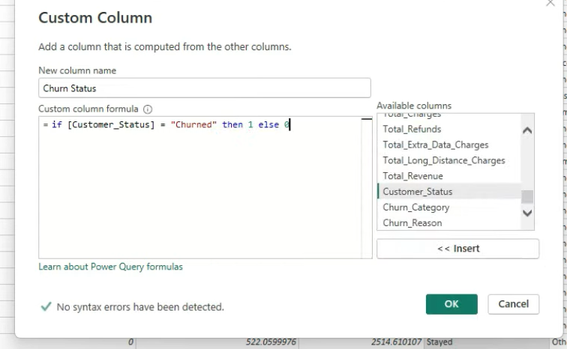

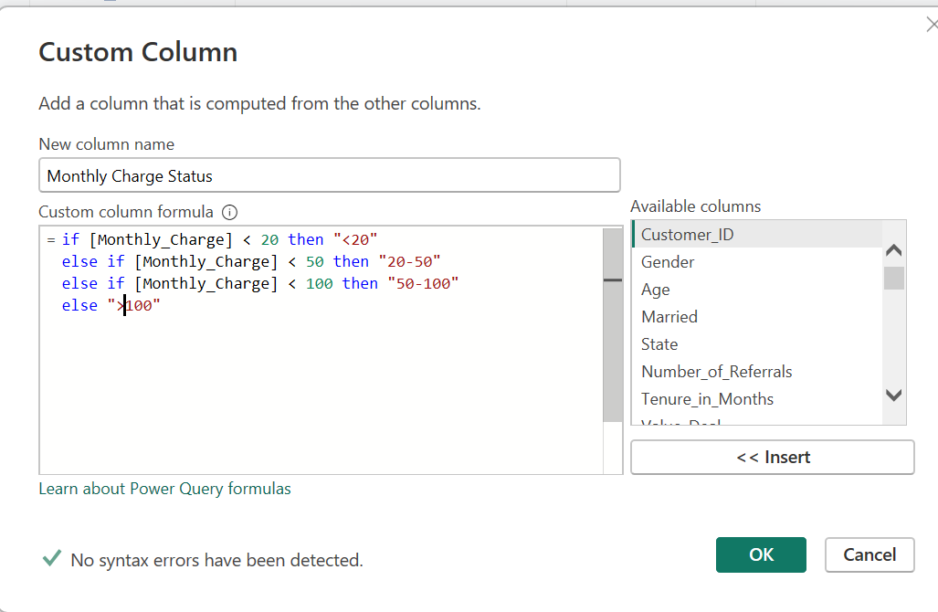

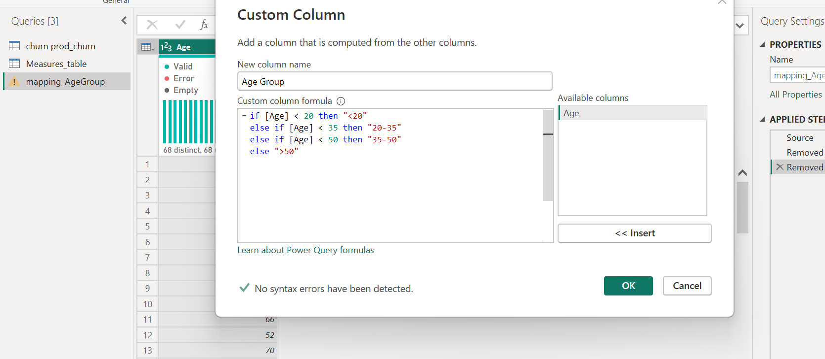

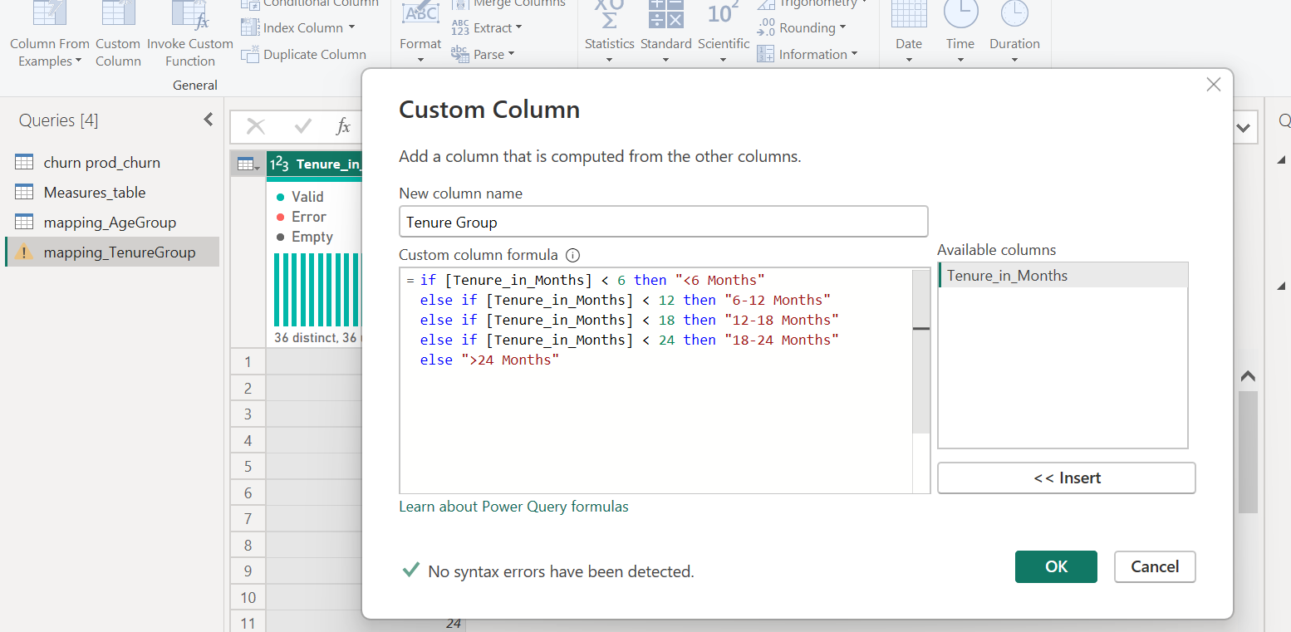

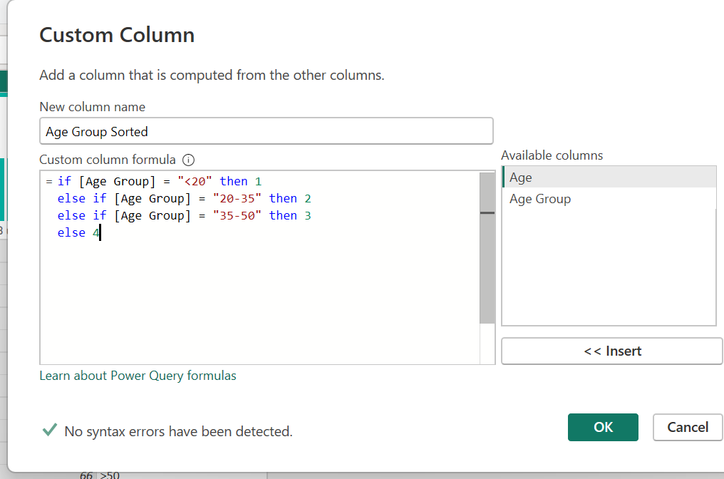

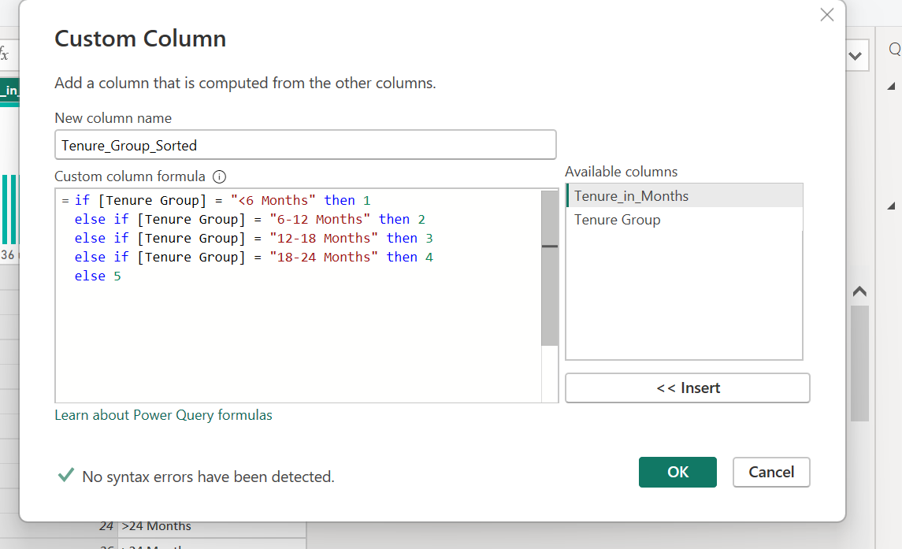

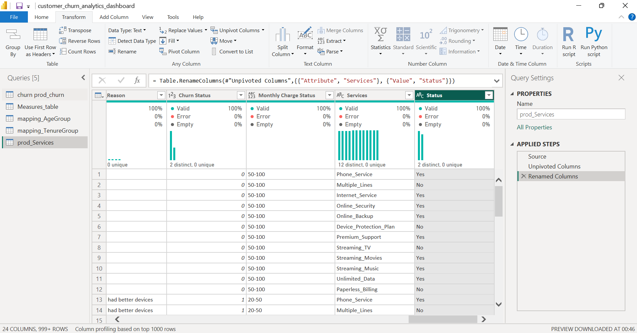

You:
- Created a reference table from churn_prod_churn
- Selected all service columns (Yes/No columns like Phone_Service, Internet_Service, Streaming_TV, etc.)
- Unpivoted columns
- Renamed:
  - Attribute → Services
  - Value → Status
👉 Resulting structure (this is IDEAL):
Reason | Churn Status | Monthly Charge Status | Services | Status
had better devices | 1 | 20–50 | Phone_Service | Yes
had better devices | 1 | 20–50 | Streaming_TV | No

This is for service-level churn analysis.

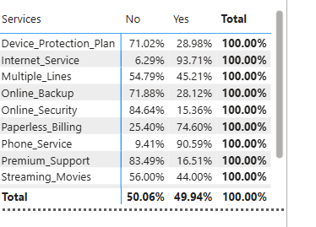

Then we used DAX measures..

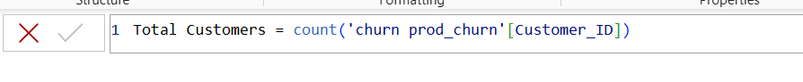
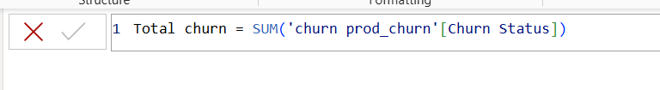
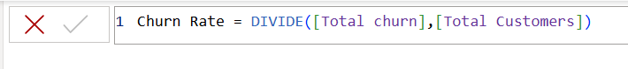

For getting India map ,(only for those who want to add map in their dashboard .. it’s optional)
You went to:
ArcGIS Map → Layers (1st icon) → Location type (last icon)
and set:
- Power BI data layer: State
- Region: India
- Geographic areas: States
- Represent location as: Points (default)

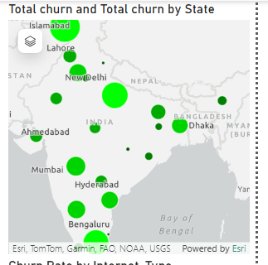

Then I added tooltips for churn reason,
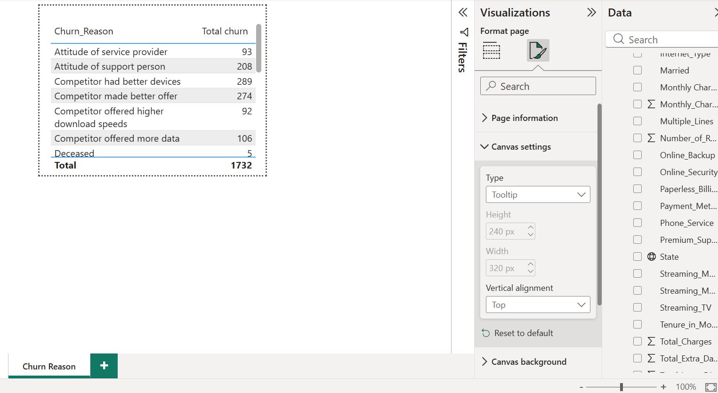

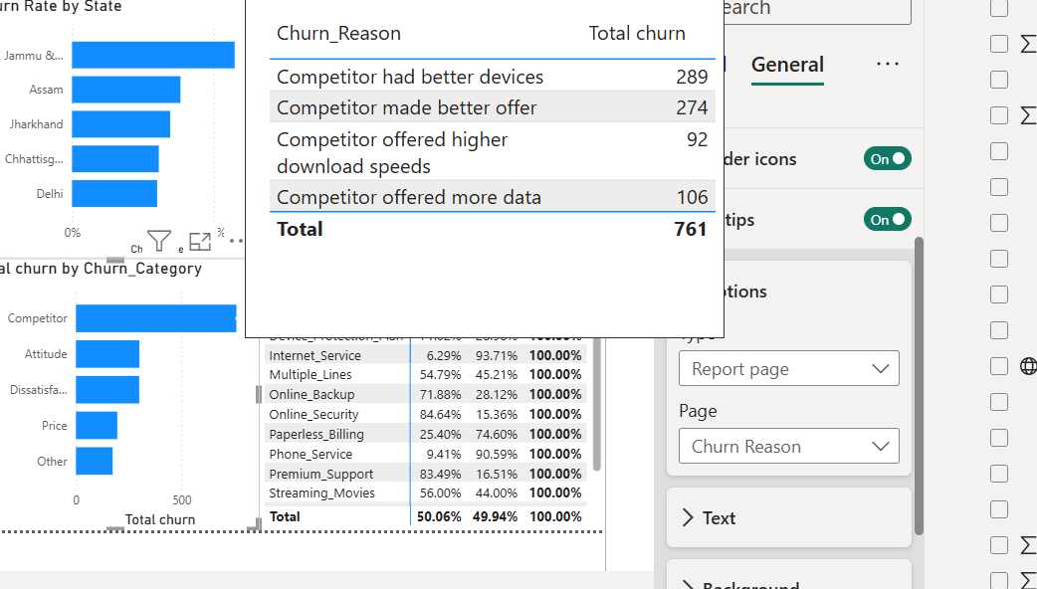
1️⃣ Created a separate Tooltip Page
- New page → renamed to Churn Reason
- Page settings:
  - Canvas settings → Type = Tooltip
  - Width / Height left default (or small)
✔️ This is exactly how Power BI tooltips should be done.

2️⃣ Added visuals on Tooltip Page
You added:
- Table
  - Rows → Churn_Reason
  - Values → Total churn
✔️ Correct
✔️ Clean
✔️ Works perfectly for hover interaction

3️⃣ Connected Tooltip to Main Dashboard
On Summary Page → Churn Category visual:
- Format → Tooltip
- Type → Report page
- Page → Churn Reason
✔️ This is the FINAL and correct step
✔️ Now hovering over any churn category shows reason-wise breakup

Step by step analysis of my dashboard
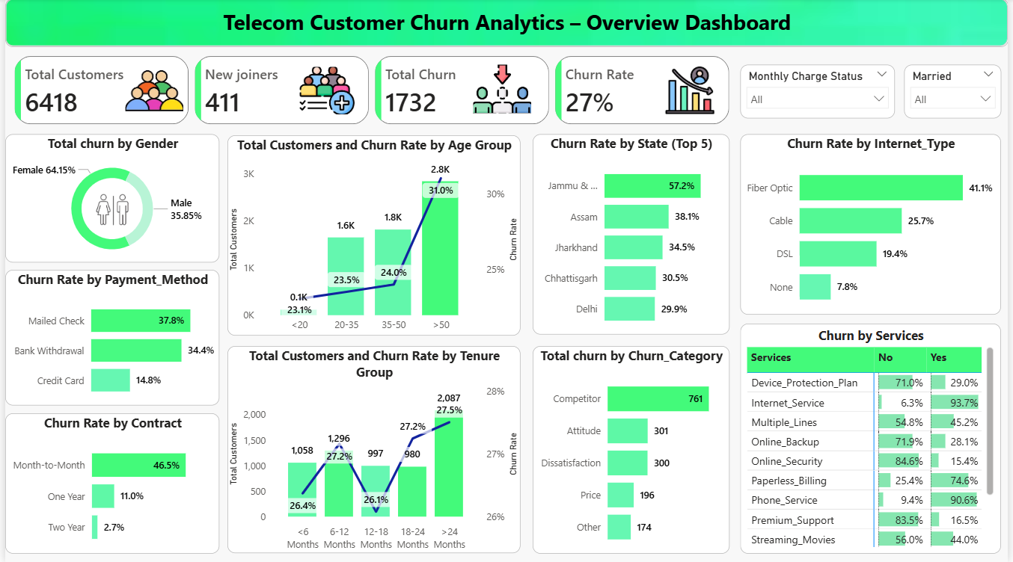

- I started with a power bi feature known as “narrative” for just basic analysis.

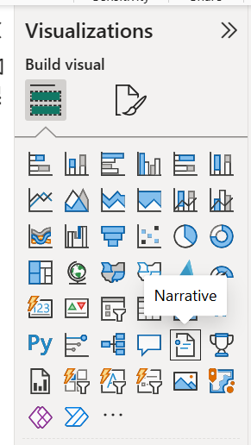

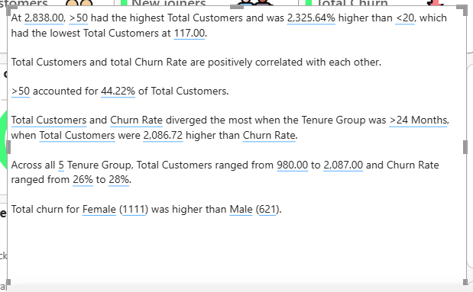

1) What this “Narrative” feature actually did
Power BI’s Smart Narrative visual:
- Automatically reads the visuals on the page
- Detects max / min / trends / correlations
- Generates machine-written observations
So this text 👇
“At 2,838.00, >50 had the highest Total Customers…”

PLEASE NOTE: This is just used only for as a starting reference, not the final answer.

Executive Summary – Telecom Customer Churn Analysis
This dashboard provides an overall analysis of customer churn in a telecom dataset, focusing on customer demographics, service usage, contract types, payment methods, and geographic distribution.
The dataset consists of 6,418 total customers, out of which 1,732 customers have churned, resulting in an overall churn rate of 27%. During the same period, 411 new customers joined the service.

Customer Demographics and Churn Behavior
Analysis by gender shows that female customers contribute a higher share of churn (64.15%) compared to male customers (35.85%). This indicates that churn is more prominent among female customers and may require targeted retention strategies.
From an age perspective, customers aged above 50 years form the largest customer segment (approximately 2.8K customers) and also exhibit the highest churn rate at 31%. In contrast, customers below 20 years represent the smallest segment with minimal impact on churn. Overall, churn rate increases gradually with age, with older customers being more likely to churn.

Geographic and Regional Insights
State-wise analysis reveals significant variation in churn rates. Among the top five states:
- Jammu & Kashmir shows the highest churn rate at 57.2%
- Followed by Assam (38.1%), Jharkhand (34.5%), Chhattisgarh (30.5%), and Delhi (29.9%)
This indicates that customer churn is influenced by regional factors such as service availability, competition, or customer experience.

Service Usage and Churn
Internet service type plays a major role in churn behavior. Customers using Fiber Optic internet show the highest churn rate (41.1%), followed by Cable (25.7%) and DSL (19.4%). Customers without internet service have the lowest churn rate at 7.8%, suggesting that dissatisfaction with high-speed internet services may be a key driver of churn.
Service-level analysis further shows that customers who do not subscribe to additional services such as Online Security, Premium Support, or Device Protection Plans tend to churn more frequently, indicating the importance of bundled services in customer retention.

Payment Method and Contract Analysis
Churn rate is highest among customers paying via Mailed Check (37.8%), followed by Bank Withdrawal (34.4%). Customers using Credit Cards show a significantly lower churn rate of 14.8%, suggesting higher stability among digitally engaged customers.
Contract type is one of the strongest indicators of churn. Customers on Month-to-Month contracts have a very high churn rate of 46.5%, whereas churn reduces sharply for One-Year contracts (11.0%) and is minimal for Two-Year contracts (2.7%). This highlights the importance of long-term contracts in reducing customer attrition.

Tenure-Based Insights
Customers with more than 24 months of tenure form the largest group with 2,087 customers and show a churn rate of 27.5%. Across all tenure groups, churn rate remains relatively stable between 26% and 28%, while the total number of customers increases with tenure. This suggests that long-term customers still require continuous engagement to prevent churn.

Churn Reasons
The primary driver of churn is competition, accounting for 761 churned customers. Other major reasons include attitude-related issues (301) and customer dissatisfaction (300). Pricing and other factors contribute comparatively less. This indicates that competitive offerings and service experience are the most critical factors influencing customer churn.

Conclusion
Overall, the analysis highlights that churn is strongly influenced by contract type, internet service quality, payment method, age group, and regional factors. Customers on month-to-month contracts, fiber optic users, older age groups, and customers in certain states are at higher risk of churn. Addressing competitive pressure, improving service quality, and encouraging long-term contracts can significantly help in reducing customer churn.

- The next analysis:
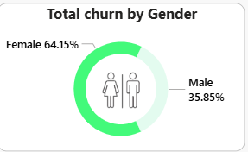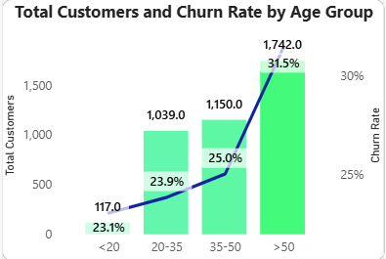

Targeted Churn Reduction Insight (Gender × Age Group)
The analysis indicates that female customers account for 64.15% of total churn, making them the most affected gender segment. Within this group, customers aged above 50 years represent the highest-risk cohort, with a churn rate of 31.5% and the largest customer base (approximately 1,742 customers).
Given the high concentration of churn within this segment, it is recommended that the business prioritize retention initiatives specifically for female customers aged above 50. Targeted actions such as personalized support, simplified service plans, loyalty incentives, and proactive customer outreach can significantly improve retention in this group.
Even a 1–2% reduction in churn within this high-volume segment could result in the retention of 15–20 customers, leading to a measurable reduction in overall churn while optimizing marketing and operational costs.
By focusing on high-impact customer segments rather than broad-based interventions, the organization can achieve more efficient churn reduction and higher return on retention efforts.
By focusing on high-impact customer segments rather than broad-based interventions, the organization can achieve more efficient churn reduction and higher return on retention efforts.

- Insight Based on Gender & State Analysis

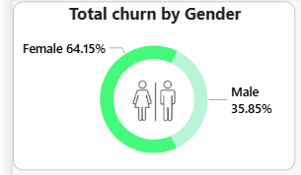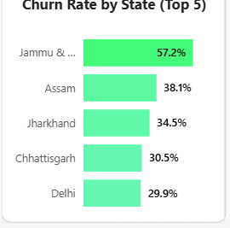

1) Gender-wise Churn Insight
- Female customers contribute 64.15% of total churn, whereas male customers account for 35.85%.
- This indicates that nearly two-thirds of churned customers are female, making gender an important demographic dimension in churn analysis.
However, when gender is used as an interactive filter, it does not significantly change churn distribution across states.
📌 Key Interpretation:
While female customers show a higher overall churn contribution, gender alone is not the primary driver of regional churn patterns.

2) State-wise Churn Insight
- Certain states consistently show high churn rates, regardless of gender selection:
  - Jammu & Kashmir (~57%)
  - Assam (~38%)
  - Jharkhand (~35%)
  - Chhattisgarh (~30%)
  - Delhi (~30%)
- Interactive analysis shows that selecting Female or Male customers does not materially alter the state-wise churn ranking or intensity.
📌 Key Interpretation:
Churn appears to be structural and region-driven, influenced more by local market conditions, competition, service quality, or infrastructure, rather than customer gender.

** Combined Insight (Gender × State)
- Although female customers form the majority of churned users, the state-level churn pattern remains stable across genders.
- This suggests that regional factors dominate churn behavior, and gender acts more as a volume indicator rather than a root cause.

** Business Recommendations (Executive Language)
1) Prioritize Region-Specific Retention Strategies
Focus churn mitigation efforts on high-risk states such as Jammu & Kashmir, Assam, and Jharkhand by addressing local service gaps, network reliability, and competitive pressures.
2) Avoid Gender-Only Retention Campaigns
Since state-wise churn does not significantly vary by gender, gender-based campaigns alone may not deliver high ROI. Retention strategies should instead be region-led.
3) Overlay Gender Within High-Churn States
While gender is not the primary churn driver, female customers within high-churn states can be treated as a secondary priority segment for targeted engagement.
4) Strengthen Regional Market Positioning
Introduce region-specific pricing, service bundles, or customer support enhancements in states with persistently high churn to improve customer stickiness.

🏁Final Executive Statement (For Report / Viva)
“The analysis shows that although female customers account for a larger share of total churn, churn patterns across states remain largely unchanged by gender. This indicates that churn is primarily driven by regional factors rather than demographic differences. Therefore, retention strategies should focus on high-churn states, with gender used as a secondary segmentation layer rather than a standalone driver.”

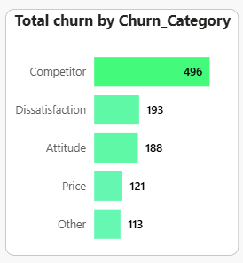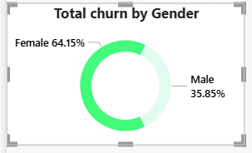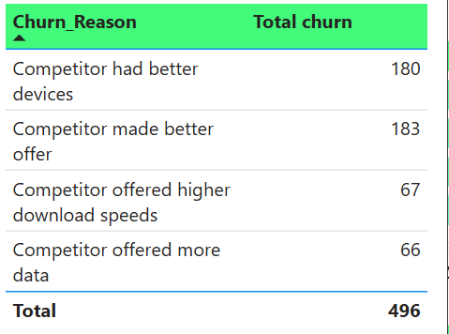
Business Insight & Recommendation (Gender × Churn Category × Reason)
The analysis reveals that female customers account for 64.15% of total churn, making them the most impacted gender segment in the customer base. When the data is further filtered for female customers, “Competitor” emerges as the dominant churn category, contributing 496 churn cases, significantly higher than other categories such as dissatisfaction, attitude, or price.
A deeper drill-down into the Competitor churn category highlights the primary drivers of churn within this segment. The most influential reasons are better device offerings (180 cases) and better pricing or promotional offers (183 cases) by competitors. Together, these two reasons form the majority of competitor-driven churn among female customers. Secondary factors such as higher download speeds and additional data benefits have a comparatively lower impact.
An important observation from the analysis is that state-level churn patterns remain largely consistent, even when filtering by gender. This indicates that churn among female customers is not strongly location-dependent, but instead driven by market competition and value perception at a national level.
** Business Recommendation
Based on these insights, the organization should prioritize competitive retention strategies targeted specifically at female customers, rather than region-specific interventions. Key actions may include:
- Introducing competitive device upgrade programs tailored for existing female customers
- Offering personalized pricing plans, bundled offers, or loyalty discounts to counter competitor pricing
- Strengthening value communication around device quality, service reliability, and long-term benefits
By addressing the top two competitor-related churn reasons, the business can potentially reduce churn more effectively than broad, non-targeted campaigns. Even a modest reduction in competitor-driven churn within this high-impact segment can result in meaningful customer retention gains, improved customer lifetime value, and better return on retention investments.

- Insight: Churn Risk Based on Service Subscription (Yes / No)
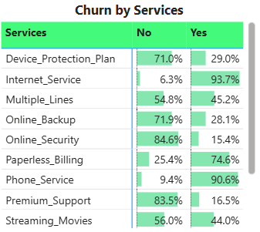
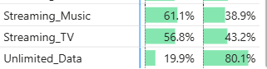

The service-level analysis highlights several critical churn risk patterns, using a threshold of 60% as a red-flag indicator. The comparison between customers who have subscribed (Yes) versus not subscribed (No) to specific services reveals meaningful behavioral signals driving churn.
Key Observations
- High churn among customers NOT subscribed to services (No > 60%):
  - Device Protection Plan (71.0%)
  - Online Backup (71.9%)
  - Online Security (84.6%)
  - Premium Support (83.5%)
  - Streaming Music (61.1%)
  - Streaming TV (56.8% – borderline)
These values indicate that customers lacking value-added or protective services are significantly more likely to churn.
- High churn among customers WHO ARE subscribed (Yes > 60%):
  - Internet Service (93.7%)
  - Phone Service (90.6%)
  - Paperless Billing (74.6%)
  - Unlimited Data (80.1%)
This suggests that core services alone are not sufficient to retain customers and may be associated with pricing sensitivity, service quality issues, or unmet expectations.

Business Interpretation
The churn behavior clearly indicates a two-sided risk:
- Customers without add-on services appear disengaged and insufficiently protected, increasing dissatisfaction and churn likelihood.
- Customers with essential services are still churning at high rates, pointing to competitive pressure, perceived lack of value, or service experience gaps rather than service availability alone.
This demonstrates that churn is not driven by service presence alone, but by how well those services meet customer expectations and perceived value.

Business Recommendations
1. Strengthen Add-On Service Adoption (Preventive Strategy)
Customers without protection and support services represent a high-risk group.
The business should:
- Bundle Device Protection, Online Security, and Backup with core plans
- Offer limited-time free trials or discounted upgrades
- Proactively educate customers on the benefits of these services
This can reduce churn by increasing customer attachment and perceived value.

2. Improve Core Service Experience (Corrective Strategy)
High churn among customers subscribed to Internet, Phone, and Unlimited Data signals experience-related issues.
Recommended actions include:
- Targeted quality audits for high-usage customers
- Competitive pricing reviews for core services
- Personalized retention offers for heavy users
- Proactive issue resolution before contract renewal

3. Focus on High-Impact Retention Opportunities
By prioritizing services where churn exceeds 60%, the organization can:
- Address churn drivers more efficiently
- Avoid blanket retention campaigns
- Improve ROI through data-driven, service-specific interventions
Even a small reduction (1–2%) in churn within these high-risk service groups can result in meaningful customer retention and revenue stabilization.

- Churn Rate by Internet Type

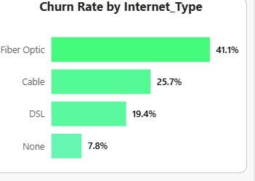

1) Insight
Customers using Fiber Optic internet experience the highest churn rate, significantly higher than Cable and DSL users. Despite being a premium and high-speed service, Fiber Optic customers are more likely to leave, suggesting dissatisfaction related to pricing, service stability, or unmet performance expectations.
In contrast, customers without any internet service show the lowest churn rate, indicating that churn is primarily driven by internet service experience rather than customer inactivity.

2) Business Recommendation
The organization should treat Fiber Optic customers as a high-priority retention segment. Given that Fiber Optic users contribute the highest churn rate (41.1%), targeted interventions in this segment can deliver immediate impact.
Recommended actions include:
- Reviewing Fiber Optic pricing and competitiveness
- Improving service reliability and speed consistency
- Proactive outreach to Fiber Optic customers showing early churn signals
- Offering loyalty benefits or service upgrades for long-term Fiber users
Even a 2–3% reduction in Fiber Optic churn could significantly reduce overall churn, as this group represents the largest and most volatile internet segment.

In a nutshell,
The analysis of churn by internet type reveals that Fiber Optic customers have the highest churn rate at 41.1%, substantially higher than Cable (25.7%) and DSL (19.4%) users. This indicates that premium service offerings alone do not guarantee customer retention and may instead increase customer expectations related to price, performance, and service quality. Customers without internet service exhibit the lowest churn rate at 7.8%, confirming that churn is primarily driven by service experience rather than service absence. To mitigate churn, the business should prioritize retention strategies for Fiber Optic users, including service quality improvements, pricing optimization, and proactive customer engagement. Targeted retention within this high-risk segment can lead to a measurable reduction in overall churn and improved customer lifetime value.

- Next

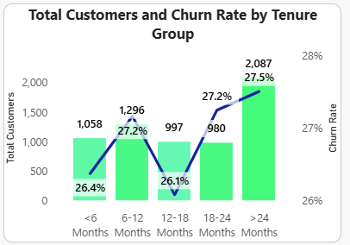

1) Insight: Churn by Tenure Group
The analysis of Total Customers and Churn Rate by Tenure Group shows a clear relationship between customer tenure and churn behavior.
- Customers with less than 6 months tenure show a churn rate of 26.4%, indicating early-stage instability.
- Churn slightly increases to 27.2% for customers in the 6–12 months group, suggesting challenges in sustaining engagement after the initial onboarding phase.
- The lowest churn rate (26.1%) is observed in the 12–18 months group, indicating a relatively stable period once customers cross the one-year mark.
- However, churn rises again for long-tenure customers, reaching 27.2% for 18–24 months and peaking at 27.5% for customers with more than 24 months tenure.
- Notably, the >24 months group also represents the largest customer base (≈2,087 customers), amplifying its overall churn impact.
2) Business Interpretation
This pattern indicates a U-shaped churn trend across tenure:
- Early churn is driven by onboarding, expectation mismatch, or initial service dissatisfaction.
- Mid-tenure customers (12–18 months) are comparatively more stable.
- Long-tenure churn (>24 months) suggests issues such as price fatigue, better competitor offers, or lack of loyalty incentives over time.
Because the highest customer volume coincides with rising churn in the longest tenure group, even small churn reductions here can have a large business impact.

3) Business Recommendation (Executive Language)
The organization should adopt a tenure-based retention strategy rather than a one-size-fits-all approach.
- For early-tenure customers (<6 months), focus on onboarding optimization, proactive support, and early engagement programs to reduce initial churn.
- For long-tenure customers (>24 months), prioritize loyalty-driven initiatives such as:
  - Personalized retention offers
  - Contract renewal incentives
  - Exclusive benefits for long-standing customers
  - Competitive pricing reviews to counter external offers
Given that the >24 months segment contributes both the highest customer count and the highest churn rate, a 1–2% churn reduction in this group alone could retain 20–40 customers, delivering a significant improvement in overall churn metrics.

- Next

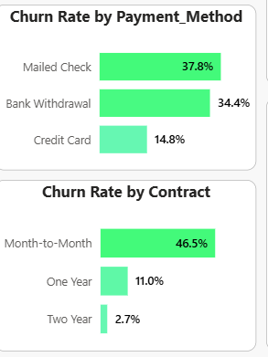
1) Insight: Churn Rate by Payment Method
The Payment Method analysis shows a noticeable variation in churn behavior across different modes:
- Mailed Check users have the highest churn rate at 37.8%, making this the most vulnerable payment segment.
- Bank Withdrawal customers also show a relatively high churn rate of 34.4%.
- In contrast, customers using Credit Cards have a significantly lower churn rate of 14.8%, indicating stronger retention and stability.
This suggests that manual or traditional payment methods are associated with higher churn, while automated and digital payment methods contribute to better customer retention.

2) Business Interpretation (Payment Method)
Higher churn among Mailed Check and Bank Withdrawal users may be driven by:
- Payment friction or delays
- Lower digital engagement
- Higher likelihood of missed or failed payments
- Less frequent customer touchpoints compared to credit card users
Credit Card users, on the other hand, benefit from auto-pay convenience, leading to smoother billing experiences and reduced churn risk.

3) Business Recommendation (Payment Method)
The business should actively encourage migration to digital payment methods, especially Credit Cards.
- Promote auto-pay and credit card enrollment through incentives such as small discounts or loyalty points.
- Introduce targeted nudges for Mailed Check and Bank Withdrawal users (e.g., reminders, simplified switch options).
- Reducing churn among high-risk payment methods by even 3–5% can lead to a meaningful improvement in overall churn while lowering operational overhead.

4) Insight: Churn Rate by Contract Type
The Contract-based churn analysis reveals a very strong relationship between contract duration and customer retention:
- Month-to-Month contracts have an extremely high churn rate of 46.5%, representing the most unstable segment.
- One-Year contracts show a much lower churn rate of 11.0%.
- Two-Year contracts perform best, with a minimal churn rate of just 2.7%.
This clearly demonstrates that longer contract commitments significantly reduce churn.

5) Business Interpretation (Contract)
Customers on Month-to-Month plans have:
- Lower switching barriers
- Higher price sensitivity
- Greater exposure to competitor offers
In contrast, long-term contracts create customer lock-in, price predictability, and stronger brand commitment, leading to substantially lower churn.

6) Business Recommendation (Contract)
Contract strategy should be a primary lever for churn reduction:
- Strongly incentivize Month-to-Month customers to upgrade to One-Year or Two-Year contracts through:
  - Discounted pricing
  - Added services or bundled benefits
  - Loyalty rewards at renewal points
- Focus retention campaigns specifically on Month-to-Month users, as they represent the highest churn risk segment.
- Even a small conversion of Month-to-Month customers into annual contracts can drastically reduce overall churn due to the large gap in churn rates (46.5% vs 11%).

Machine Learning Phase

📌 Random Forest – Definition (for Project Documentation)
I am going to use Random Forest for prediciting customer churn. Random Forest is a supervised machine learning algorithm used for classification and regression tasks. It works by building multiple decision trees on different subsets of the data and then combining their results to make a final prediction.
Instead of relying on a single decision tree, Random Forest takes a majority vote (for classification) from all trees, which helps improve accuracy and reduce overfitting.

📌 Why Random Forest is Used for Churn Prediction
Random Forest is well-suited for customer churn prediction because:
- It can handle both numerical and categorical features
- It captures complex and non-linear relationships in customer behavior
- It is robust to noise and missing values
- It reduces the risk of overfitting compared to a single decision tree
- It provides feature importance, helping identify key drivers of churn

📌 Role of Random Forest in This Project
In this project, the Random Forest classifier is used to predict whether a customer is likely to churn or not based on factors such as tenure, contract type, payment method, internet service, and service subscriptions.
The model helps the business move from descriptive analysis (what happened) to predictive analytics (what is likely to happen next), enabling proactive customer retention strategies.

Now if we remember we had created separate Views in MySQL, that we will be using as a prediciton datset,
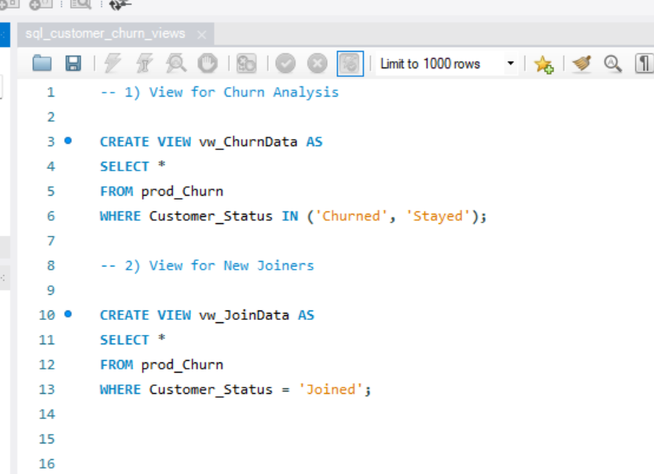

    - Loading View in E
xcel

After connecting it to mysql server
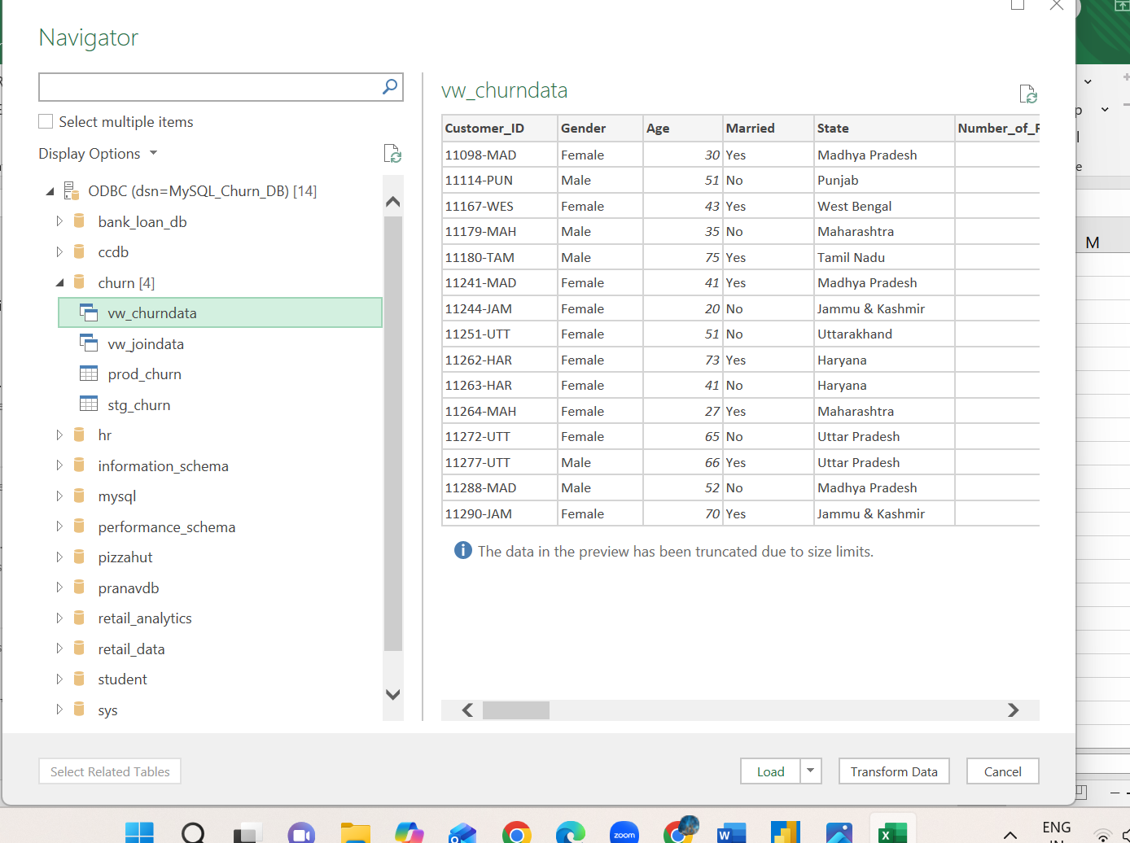

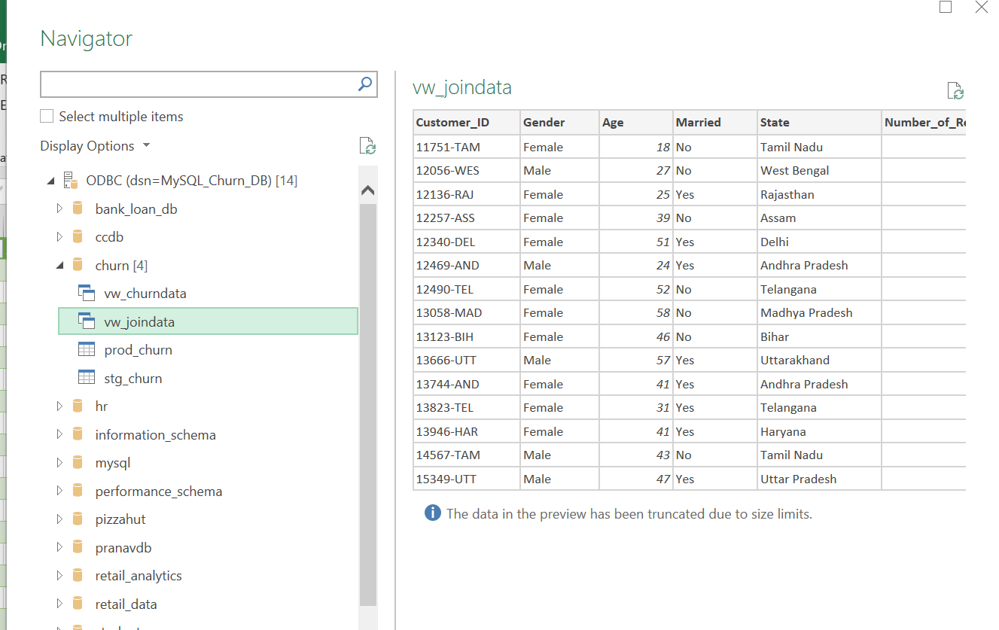

How Data Was Imported into Excel from MySQL (Explain Simply)
To use the SQL views for machine learning preparation:
- A MySQL ODBC connection was configured
- Excel connected to the database using ODBC
- The SQL views (vw_churndata, vw_joindata) were selected from the Navigator
- Data was loaded directly into Excel for preprocessing and modeling
This ensures the model always uses live, database-validated data.

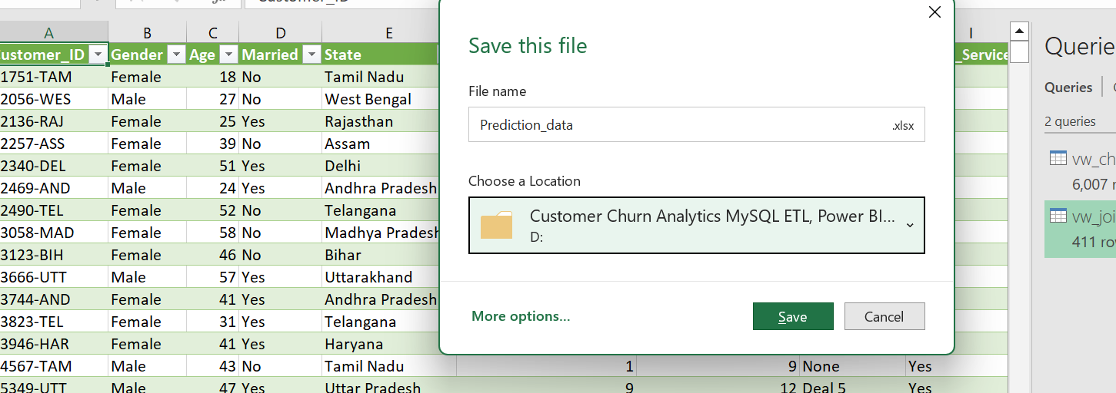

📊 Model Evaluation & Interpretation
Customer Churn Prediction

🔹 Model Used
- Algorithm: Random Forest Classifier
- Approach: Supervised Classification
- Target Variable: Customer_Status
  - 0 → Stayed
  - 1 → Churned
- Data Split: Train–Test Split
- Prediction Method Used:
- rf_model.predict(X_test)
(No probability-based prediction used)

🔹 Model Evaluation Results
📌 Classification Report
Class | Precision | Recall | F1-Score
Stayed (0) | 0.86 | 0.92 | 0.89
Churned (1) | 0.78 | 0.65 | 0.71
Accuracy |  |  | 0.84

🔹 Confusion Matrix Interpretation
[[783 64]
[126 229]]
Actual \ Predicted | Stayed (0) | Churned (1)
Stayed (0) | 783 | 64
Churned (1) | 126 | 229
What this means:
- 783 customers who stayed were correctly predicted as stayed
- 229 churned customers were correctly identified
- 126 churned customers were missed (predicted as stayed)
- 64 customers were wrongly flagged as churned

🔹 Metric Interpretation (Simple & Correct)
✅ Accuracy (84%)
- The model correctly predicts 84% of all customers
- Indicates strong overall performance
- However, accuracy alone is not enough for churn problems

✅ Precision (Churned = 0.78)
- When the model predicts a customer will churn:
  - It is correct 78% of the time
- This means false churn alerts are reasonably low

⚠️ Recall (Churned = 0.65)
- The model detects 65% of actual churners
- About 35% of churned customers are missed
- This is a known limitation of the baseline model
⚠️ Missing churners can impact business retention strategies

✅ F1-Score (Churned = 0.71)
- Balanced measure between precision and recall
- Indicates the model performs fairly well for churn prediction

🔹 Feature Importance (as per Instructor)
The Random Forest model identified key drivers of churn such as:
- Contract Type
- Total Revenue
- Monthly Charges
- Tenure in Months
- Internet Type
- Age
These features were visualized using a feature importance bar chart.

🔹 Prediction on New Customers (Join Data)
After model evaluation, the trained model was used to predict churn for newly joined customers (vw_JoinData):
✔ Same preprocessing
✔ Same label encoders
✔ Same trained Random Forest model
new_predictions = rf_model.predict(new_data)
Only customers predicted as Churned (1) were retained and exported.

🔹 Final Output
- Output File Generated: churn_risk_customers.csv
- Contains:
  - Customer details
  - Predicted churn status
- Used directly in Power BI for:
  - Churn risk analysis
  - Business insights
  - Decision support dashboards

Now, lets try to improve our recall as we don’t want to loose customers who have churned away and we would like to retain them.
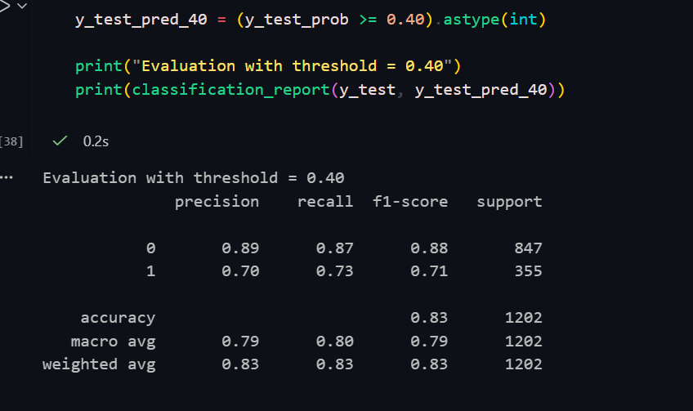

Perfect — you’re done with ML and you did it the right way.
Below is a clean, final Markdown section you can paste directly into your Jupyter Notebook (Markdown cell) and reuse in your Word report with minimal edits.
I’ve written everything using “I”, aligned strictly with what you actually did, and included both evaluation tables (before & after threshold tuning).

🔍 Machine Learning Model Development & Evaluation (Customer Churn Prediction)
1️⃣ Model Overview
In this phase, I built a Customer Churn Prediction model using the Random Forest Classifier.
The objective was to identify customers who are likely to churn based on their demographic, service usage, billing, and contract-related attributes.
- Algorithm Used: Random Forest Classifier
- Reason for Selection:
  - Handles both numerical and categorical features effectively
  - Robust to noise and overfitting
  - Provides strong baseline performance without heavy tuning

2️⃣ Model Training
I trained the model using the cleaned and encoded dataset.
rf_model = RandomForestClassifier(n_estimators=100, random_state=42)
rf_model.fit(X_train, y_train)
The dataset was split into training and testing sets to ensure unbiased evaluation.

3️⃣ Initial Model Evaluation (Default Threshold = 0.50)
After training, I evaluated the model using the default classification threshold (0.50).
📊 Initial Evaluation Metrics
Class | Precision | Recall | F1-Score
Stayed (0) | 0.86 | 0.92 | 0.89
Churned (1) | 0.78 | 0.65 | 0.71
Accuracy |  |  | 0.84
Key Observation:
- The overall accuracy was 84%, which is good.
- However, recall for churned customers (65%) was relatively low.
- This means the model was missing some actual churners, which is risky for business use.

4️⃣ Improving Recall Using Probability Threshold Tuning
Since predicting churn correctly is more important than overall accuracy, I decided to use probability-based predictions and adjusted the decision threshold.
Instead of using only class predictions, I used:
y_test_prob = rf_model.predict_proba(X_test)[:, 1]
y_test_pred_40 = (y_test_prob >= 0.40).astype(int)
This lowers the threshold from 0.50 → 0.40, allowing the model to identify more potential churners.

5️⃣ Improved Model Evaluation (Threshold = 0.40)
📊 Improved Evaluation Metrics
Class | Precision | Recall | F1-Score
Stayed (0) | 0.89 | 0.87 | 0.88
Churned (1) | 0.70 | 0.73 | 0.71
Accuracy |  |  | 0.83

6️⃣ Comparison: Before vs After Threshold Tuning
Metric | Initial Model (0.50) | Improved Model (0.40)
Accuracy | 0.84 | 0.83
Churn Recall | 0.65 | 0.73
Churn Precision | 0.78 | 0.70
Interpretation:
- Accuracy dropped slightly (acceptable trade-off).
- Recall for churned customers improved significantly.
- The model now captures more at-risk customers, which is more valuable from a business perspective.

7️⃣ Prediction on New (Joined) Customer Data
After finalizing the model, I applied it to newly joined customer data (vw_JoinData).
Key steps performed:
- Loaded new customer data
- Applied the same preprocessing & label encoding
- Generated churn probabilities
- Applied the optimized threshold (0.40)
- Filtered only customers predicted as churn-risk
new_prob = rf_model.predict_proba(new_data)[:, 1]
new_predictions = (new_prob >= 0.40).astype(int)

original_data['Churn_Probability'] = new_prob
original_data['Customer_Status_Predicted'] = new_predictions

churn_risk_customers = original_data[
original_data['Customer_Status_Predicted'] == 1
]

8️⃣ Final Output
- The final output file Churn_Risk_Customers_Predictions.csv contains:
  - Original customer details
  - Churn probability
  - Final churn prediction label
This dataset is now ready to be used in Power BI for:
- Risk segmentation
- Priority targeting
- Business decision-making dashboards

✅ Final Conclusion
I successfully:
- Built a Random Forest churn prediction model
- Evaluated and interpreted classification metrics
- Improved churn recall using probability threshold tuning
- Generated actionable churn-risk predictions for new customers
This completes the Machine Learning phase of the project and provides a strong foundation for Power BI analytics and business insights.

Final phase:POWER BI 2nd dashboard

      - Dax Measures
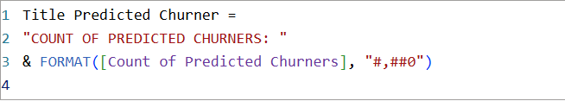

    - Final outputs:
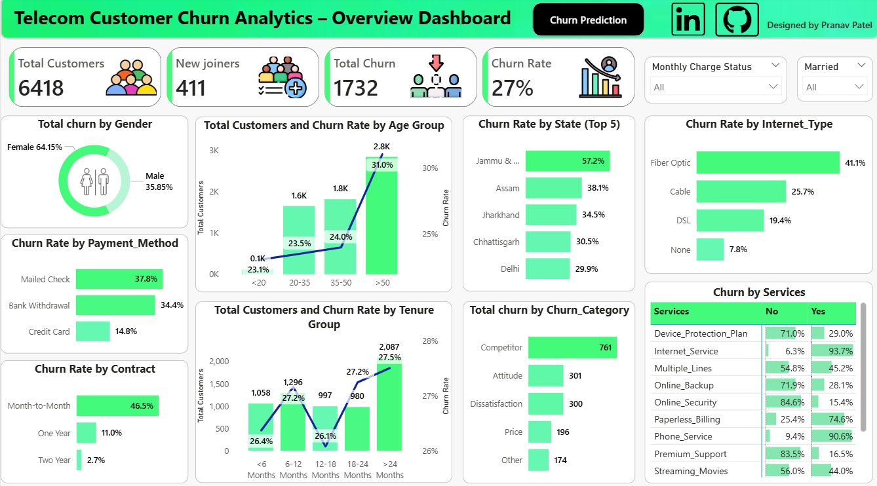
Figure: Overview Dashboard

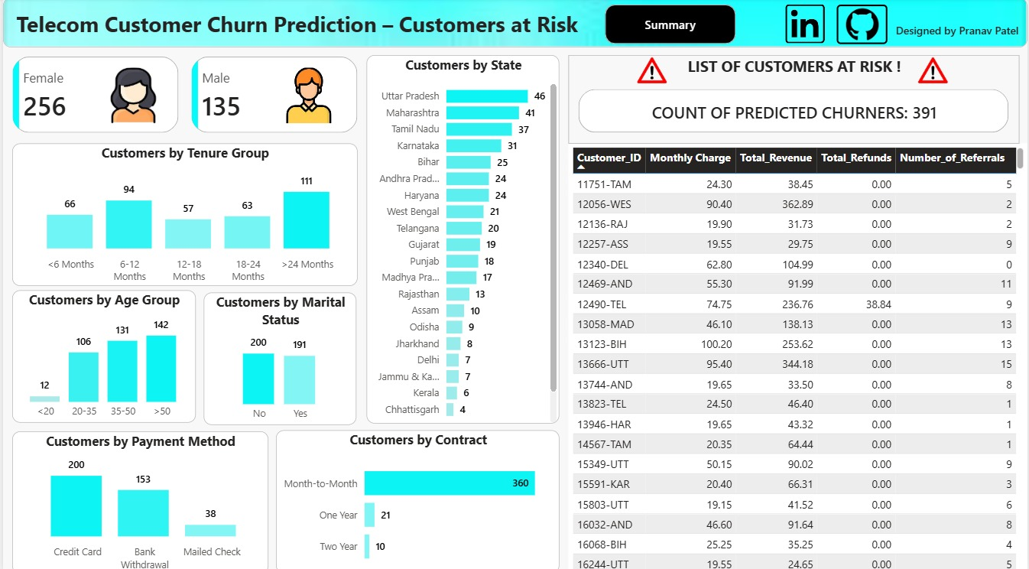
Figure: Prediction Dashboard

